[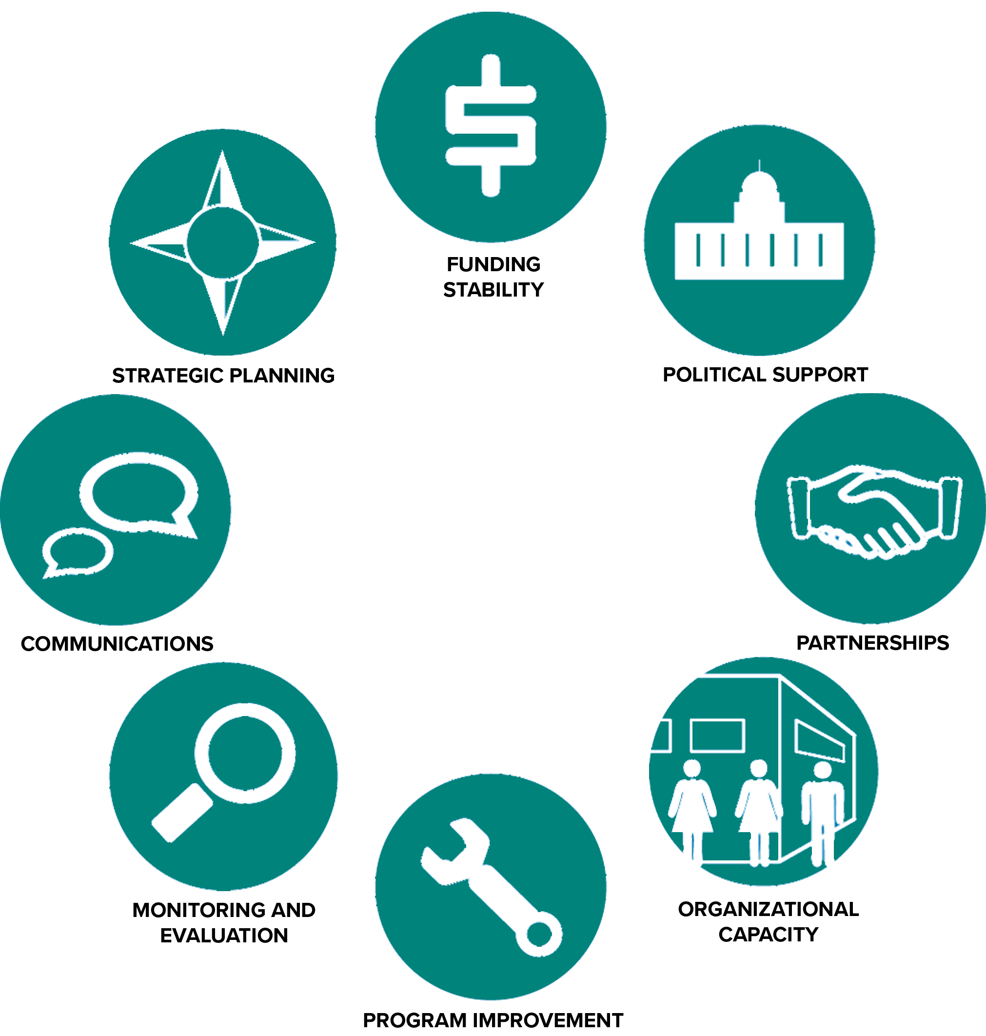](https://www.google.ca/url?sa=i&rct=j&q=&esrc=s&source=images&cd=&cad=rja&uact=8&ved=0ahUKEwj7lNPxi8XYAhUs34MKHYMPDaQQjRwIBw&url=http://sienaconsulting.ca/8-criteria-for-building-organizational-sustainability/&psig=AOvVaw1XbvlKtlFt_OZf6I9e_wY_&ust=1515388409907947)

**CHRISTIAN SENIOR CITIZENS HOMES SOCIETY OF NORTHERN ALBERTA**

**Sustainability Plan**

**2021-23**

**Organizational Health Pillars**

The organizational pillars will help the Society provide balance between the most critical aspects of our organization’s overall ongoing health and sustainability. Our annual planning and intentional work throughout the organization should encompass each of these pillars and the desired outcomes within.

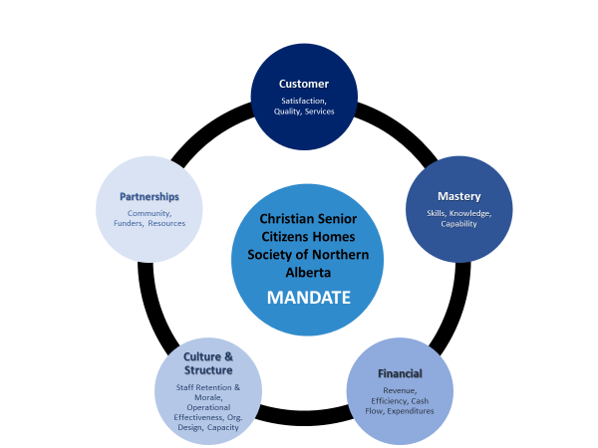

**Annual Required Outcomes**The following outcomes serve as a foundational framework for ongoing organizational health, success, and sustainability.

|  |  |
| --- | --- |
| **Customer** | 1. Evidence exists to demonstrate Residents have a strong sense of well-being, choice, and independence to live the live they want to live. 2. Families are actively involved in the life of their family member. 3. The Society is Accreditation certified with systems in place to ensure ongoing best practices. 4. Rotating annual surveys demonstrate a high level of satisfaction for staff and residents/families. 5. Services are individualized and able to meet the needs of all residents in service. 6. Service standards exceed basic health and safety requirements on an ongoing basis. 7. Families/residents are satisfied and supported through entire Intake to Service to move out process. 8. Facilities (common-areas, administration, and exteriors) are well-maintained and allow for safe and secure environments. 9. Our communal spaces are functional and welcoming. 10. Social/leisure services support physical, mental, spiritual, and emotional health, and are community-based where possible. 11. Residents and families have access to applicable policies and procedures that affect them. 12. Effective monitoring systems are in place. 13. Preparation and service of meals and snacks meets food handling and nutritional requirements. |
| **Financial** | 1. The Society operating budgets for overall operation fall within approved financial plans. 2. An equipment and capital facility capital maintenance plan are in place. 3. All financial investments for THE SOCIETY are risk adverse, on a continual growth plan, and are ethical according to Christian values. 4. A process is in place to accept donations and endowments of cash and in-kind gifts. 5. Revenues exceed expenditures on a consolidated basis. 6. A minimum of 3 month’s cash flow contingency is always available. 7. A positive ratio of assets over liabilities always exists. 8. Financial reporting is timely within 30 days of end of month and is accurate. 9. A responsible spending plan is in place to ensure ongoing efficiencies and is understood by all expense eligible staff members, that ensures revenues exceed expenditures. 10. A comprehensive and thorough insurance plan is in place for the Society, our operations, our facilities, and our staff/directors/contractors. 11. Grants are researched, and applications made to offset program/operational initiatives where possible. |
| **Mastery** | 1. Skills and competencies of staff meet the needs of all Residents. 2. Skills and competencies of staff meet the support needs of the organization. 3. Leadership and Board of the organization are united on organizational health & sustainability. 4. Funds are available for required staff training, and accessible through a defined process for elective training. 5. Staff follow a mandatory training program. 6. Opportunities for new learnings are secured, through peer mentorship network, Executive Coaching and/or leadership development training courses for Leadership and Coordination level staff. 7. Board completes regular orientation and collective development initiatives. 8. A plan exists to nurture the professional growth and development of staff. |
| **Organization & Structure** | 1. Culture and morale across the organization is positive. 2. Communication, alignment, and connectivity exists throughout the organization. 3. Staff turnover is consistent with (or less than) provincial sector average. 4. Retention of existing staff is our choice. 5. The structure is as efficient as possible and optimizes use of staffing funds. 6. Clear roles, responsibilities and accountabilities are in place. 7. Staff across the organization are aware of, and consistently practice policies and procedures. 8. Capacity exists within the mid and senior level leadership to accommodate growth of the organization. 9. A comprehensive performance review and accountability system exists across the organization for all staff. 10. Continuous improvement is regularly explored and implemented. 11. A comprehensive compensation & review process exists to ensure marketability. 12. Risk management is effectively evaluated to identify and mitigate risks. 13. All staff, leaders and board members are approachable, professional, and accountable. 14. Opportunities exist for staff to be engaged/participate in the development of policies, procedures and overall health and direction of the Society. |
| **Partnerships / Community** | 1. Program and Society resources are increased through sharing with community partners where applicable. 2. Relationships with partners, vendors etc. are mutually beneficial. 3. Relationships with new partnerships are being sought/developed annually. 4. The Society’s image in the community is positive and reputable, demonstrate ability to develop and maintain positive relationships with partners, stakeholders, and government. 5. Society is represented at community events, and important Society functions promoting the Society wherever and however possible. 6. Liaises with and participates in sector-wide (i.e. ASCHA) activities to help advance disability services. |