[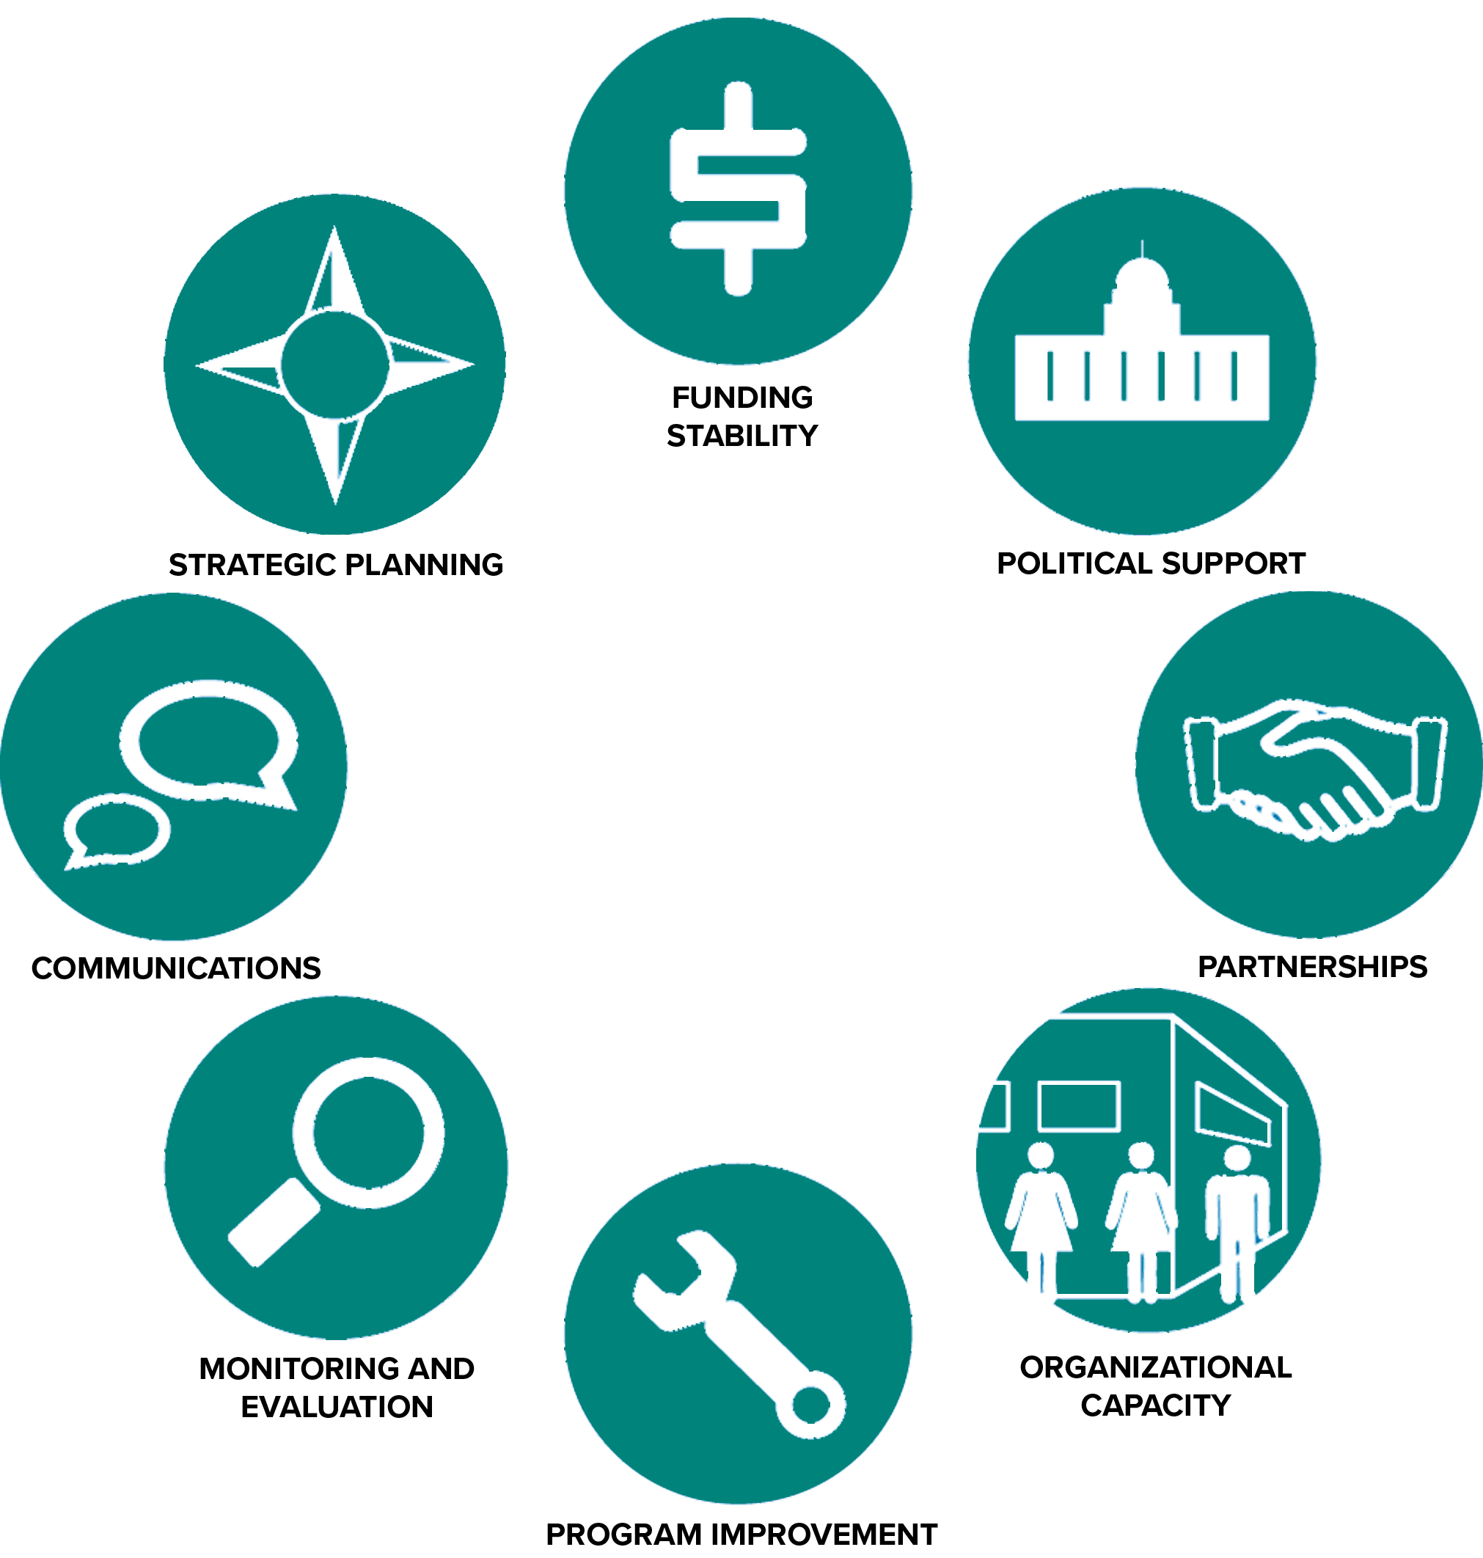](https://www.google.ca/url?sa=i&rct=j&q=&esrc=s&source=images&cd=&cad=rja&uact=8&ved=0ahUKEwj7lNPxi8XYAhUs34MKHYMPDaQQjRwIBw&url=http://sienaconsulting.ca/8-criteria-for-building-organizational-sustainability/&psig=AOvVaw1XbvlKtlFt_OZf6I9e_wY_&ust=1515388409907947)

**CHRISTIAN SENIOR CITIZENS HOMES SOCIETY OF NORTHERN ALBERTA**

**Sustainability Plan**

**2021-23**

**Purpose**

A Christian provider serving the Christian community.

**Core Values**

**Integrity Caring Excellence**

* We keep our commitments, and we are accountable.
* We have a “can do” attitude; we are problem-solvers.
* We are good stewards.
* We are team players.
* We treat our residents and each other with respect, without exception.
* We take our jobs seriously, but not ourselves.
* We communicate openly and value all opinions and views.
* We celebrate our successes.
* We show pride, enthusiasm and dedication in everything we do.
* We look for better ways to do things

**Organizational Health Pillars**

The organizational pillars will help the Society provide balance between the most critical aspects of our organization’s overall ongoing health and sustainability. Our annual planning and intentional work throughout the organization should encompass each of these pillars and the desired outcomes within.

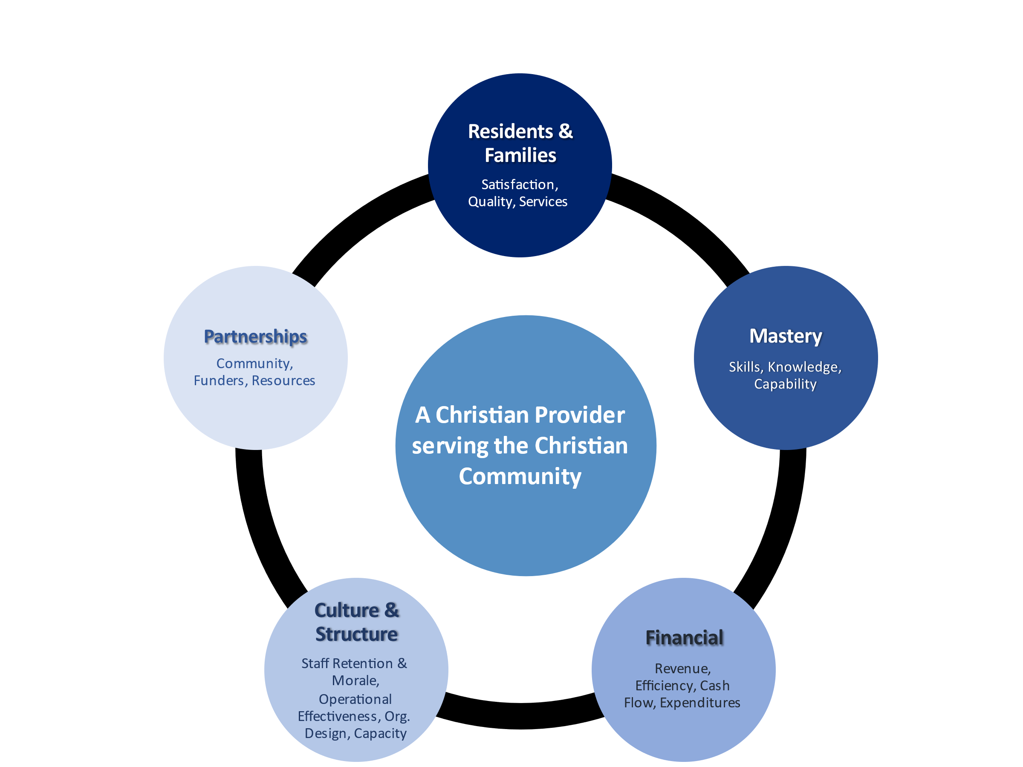

**Annual Required Outcomes**The following outcomes serve as a foundational framework for ongoing organizational health, success, and sustainability.

|  |  |
| --- | --- |
| **Residents / Families** | 1. Evidence exists to demonstrate residents have a strong sense of well-being, choice, and independence to live the life they want to live. 2. Families are actively involved in the life of their family member. 3. Annual & periodic surveys demonstrate a high level of satisfaction for staff and residents/families. 4. Services are individualized and able to meet the needs of all residents in service. 5. Service standards exceed basic health and safety requirements on an ongoing basis. 6. Families/residents are satisfied and supported throughout the entire process from initial contact to move-out. 7. Facilities (common-areas, administration, and exteriors) are well-maintained and allow for safe and secure environments. 8. Our communal spaces are functional and welcoming. 9. Social/leisure services support physical, mental, spiritual, and emotional health, and are community-based where possible. 10. Residents and families have access and input to applicable policies and procedures that affect them. 11. Effective monitoring systems are in place. 12. Preparation and service of meals and snacks meets food handling and nutritional requirements. |
| **Financial** | 1. The Society operating budgets for overall operation fall within approved financial plans. 2. An equipment and capital facility/maintenance plan are in place. 3. All financial investments for THE SOCIETY are risk averse, on a continual growth plan, and are ethical according to Christian values. 4. A process is in place to accept donations and endowments of cash and in-kind gifts. 5. Revenues exceed expenditures on a consolidated basis. 6. A minimum of 3 month’s cash flow contingency is always available. 7. A positive ratio of assets over liabilities always exists. Debt equity ratio 8. Financial reporting is timely within 30 days of end of month and is accurate. 9. A responsible spending plan is in place to ensure ongoing efficiencies and is understood by all expense eligible staff members, that ensures revenues exceed expenditures. 10. A comprehensive and thorough insurance plan is in place for the Society, our operations, our facilities, and our staff/directors/contractors. 11. Grants are researched, and applications made to offset program/operational initiatives where possible. 12. Financial audit |
| **Mastery** | 1. Skills and competencies of staff meet the needs of all Residents. 2. Skills and competencies of staff meet the support needs of the organization. 3. Leadership and Board of the organization are united on organizational health & sustainability. 4. Funds are available for required staff training, and accessible through a defined process for elective training. 5. Staff follow a mandatory training program which is documented. 6. Opportunities for new learnings are secured, through peer mentorship network, Executive Coaching and/or leadership development training courses for Leadership and Coordination level staff. 7. Board completes regular orientation and collective development initiatives. 8. A plan exists to nurture the professional growth and development of staff. |
| **Organization & Structure** | 1. Culture and morale across the organization is positive. 2. Communication, alignment, and connectivity exists throughout the organization. 3. Staff turnover is consistent with (or less than) provincial sector average. 4. Retention of existing staff is our choice. 5. The structure is as efficient as possible and optimizes use of staffing funds. 6. Clear roles, responsibilities and accountabilities are in place. 7. Staff across the organization are aware of, and consistently practice policies and procedures. 8. Capacity exists within the mid and senior level leadership to accommodate growth of the organization. 9. A comprehensive performance review and accountability system exists across the organization for all staff. 10. Continuous improvement is regularly explored and implemented. 11. A comprehensive compensation & review process exists to ensure marketability. 12. Risk management is effectively evaluated to identify and mitigate risks. 13. All staff, leaders and board members are approachable, professional, accountable and foster the values outlined in the Society’s Statement of Faith. 14. Opportunities exist for staff to be engaged/participate in the development of operational policies, procedures and overall health and direction of the respective sites. 15. Annual general meeting 16. The Society is a non-profit organization with charitable status in good standing and is in compliance with all legislative requirements. |
| **Partnerships / Community** | 1. Program and Society resources are increased through sharing with community partners where applicable. 2. Relationships with partners, vendors etc. are mutually beneficial. 3. Relationships with new partnerships are being sought/developed annually. 4. Strong visibility within and relationships with our supporting churches. 5. Strong relationships exist with current and potential donors. 6. The Society’s image in the community is positive and reputable, demonstrate ability to develop and maintain positive relationships with partners, stakeholders, and government. 7. Society is represented at community events promoting the Society wherever and however possible. 8. Liaises with and participates in sector-wide activities to help advance senior living services. |

**POTENTIAL STRATEGIES 2021-2023**

1. Enhanced Services

* Increased long-term care
* Palliative - End of life services
* Each site has a range of services
* At-home independent living care programs
* Consulting Services to other Seniors Living organizations
* Chaplain Services
* Affordability MUST be maintained
* Preference is to not be reliant on/controlled by AHS

1. Geographical Growth

* Increasing presence beyond the Edmonton and/or Northern Alberta region

1. Community (Integration of community and programming)

* Partnerships with other Christian entities

1. Leave the services as they are