

**Christian Senior Citizens Homes Society**

**Of Northern Alberta**

Created:

March 2019

**GOVERNANCE**

**&**

**EXECUTIVE LIMITATIONS**

**GOVERNANCE – Functional Overview**

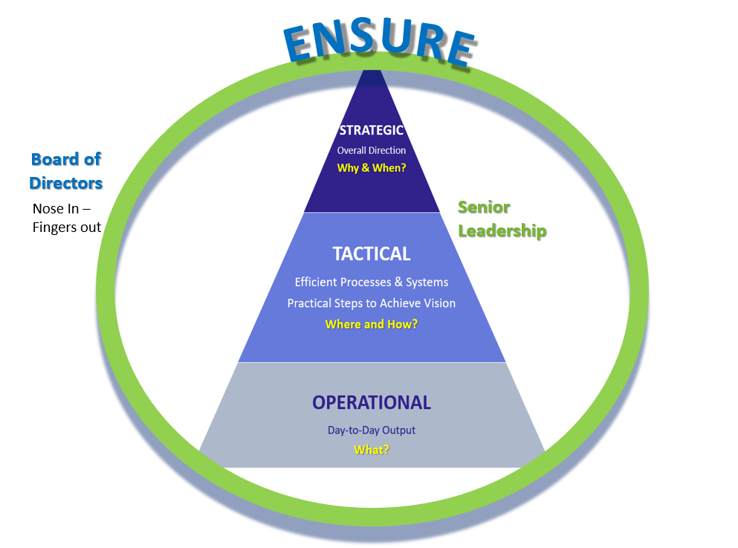

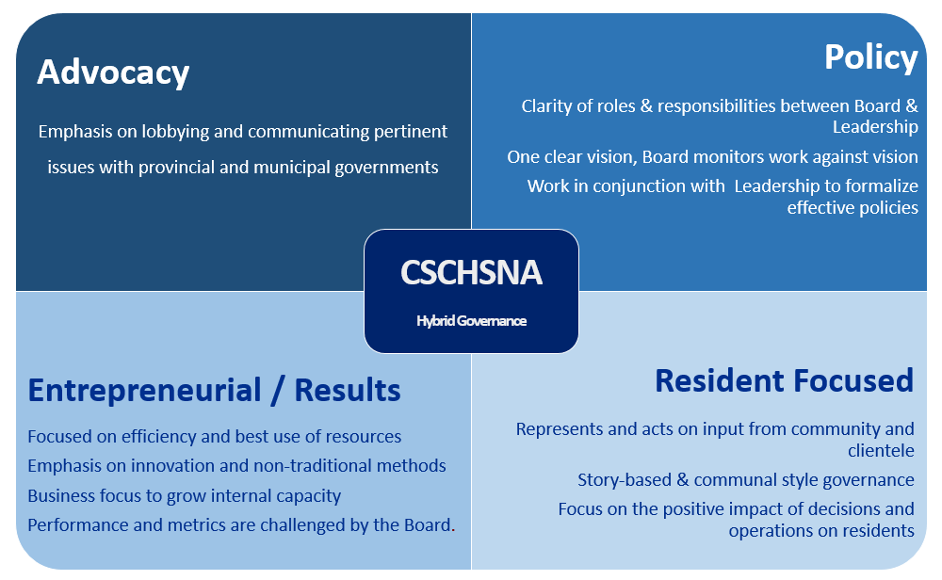

**GOVERNANCE – Responsibilities**

|  |  |  |
| --- | --- | --- |
| **Board of Directors** | **Governance Responsibility** | **Executive Director** |
| * Clearly understand the nature of services (sets mandate), and ensures that services are of high quality. * Govern CSCHSNA on behalf of the Christian Reformed community according to its mandate and values. | **Stakeholder Benefit** | * Provide regular updates on service successes and challenges. * Balance stakeholder interests with those of the Organization. * Provide recommendations on rationale for large scale, or large impact changes to services. |
| * Ensures mission and mandate are never compromised. * Respectful of current priorities & approves all newly developed policies. * Ensures comprehensive grievance (resident & staff) processes and policies are followed. * Conducts annual performance review on Executive Director complete with compensation review. * Is aware of, and provides direction (according to legal advice) on legal matters that can negatively affect the organization. Ensures the organization is protected. * Ensure a comprehensive Risk Management and business continuity plan is in place. | **Fiduciary: Organizational Stewardship** | * Hold all staff accountable to mandate. * Make recommendations where necessary to amend mandate. * Monitors the ongoing health and sustainability of the Organization. |
| * Ensures an effective Strategic Development Committee is in place and follows Terms of Reference. * Ensures Leadership is aligned with Board on organizational direction. | **Strategic Evolution & Growth** | * Works with Strategic Development Committee to review and evaluate potential growth & development opportunities. |
| * Ensures investments into services and facilities are thoroughly planned out. * Assurance of funding contracts & subsequent obligations. * Set financial commitment levels for Executive Leadership. * Ensure spending parameters are in place. * Ensures sound auditing processes are in place. | **Financial Viability** | * Utilizes funds responsibly to maximize resources. * Brings financial concerns to the attention of the Board. |
| * Ensure an operational sustainability plan is in place complete with health pillars and outcomes; and is reviewed quarterly. | **Operational Efficiency** | * Keeps the Board aware of organizational pressures that can limit the effectiveness & efficiency of the organization |
| * Provide support for political lobbying where required. * Chairperson acts as the official voice of the organization for all politically related matters. | **Ambassadorial & Advocacy** | * Acts as the official organizational voice for all external matters not political. |
| * Ensures resident feedback & service improvement processes are in place. * Ensures metrics are in place to measure to meet required annual operating outcomes. * Ensure ongoing continuous improvement processes exist. | **Reflection & Assessment** |  |
| * Scrutinizes and approves all nominations/appointments. * The Chairperson will ensure the integrity of the Board’s process. * Board committees can be created by collective approval of the Board. The existence and charge of any Committee (standing or ad hoc) will be represented by an official Terms of Reference as approved by the Board. | **Board Development** | * Assists with the coordination for Board recruitment. Responsible for the screening of all potential applicants prior to election. |

**GOVERNANCE – Executive Limitations**

|  |  |
| --- | --- |
| **Board of Directors** | **Executive Director** |
| 1. The Board’s sole connection to the operational organization, its achievements and conduct will be through the Executive Director. 2. Only the Executive Committee of the Board acting as a collective body can be involved in matters relating to employment, termination, discipline or change the conditions of employment of the Executive Director. 3. Decisions, evaluations or instructions of individual Board Members to the Executive Director or staff are not binding unless the Board as a collective have authorized the authority. 4. Individual Board members will not act, represent the organization, or make decisions independently of the Board’s approval and Executive Director involvement. 5. The Board will direct the Executive Director to achieve specific mutually agreed upon results (pillars/outcomes) for the organization and ensure relevant metrics exist for review. 6. Individual Board members will ensure a climate of positive collaboration, decorum and common outcomes-focus at all times. 7. Individual Board members will avoid any conflict of interest whether real or perceived that supersedes their responsibility to CSCHSNA. Potential conflict shall be declared and noted in minutes. The member will remove themselves from all related discussions, votes and decisions. | 1. All Board authority is delegated to the Executive Director so that accountability of staff is considered to be accountability to the Executive Director. 2. As long as the Executive Director uses reasonable interpretation of the organization’s mandate, resources and policies, they are authorized to make all operational decisions, take all actions and establish practices to progress and safeguard the organization. 3. The Executive Director shall not cause or permit any activity or practice that is illegal, imprudent or in violation of commonly accepted business practices, regulations or laws. 4. The Executive Director will ensure a climate of positive collaboration and common outcomes-focus at all times. 5. The Executive Director will not alter the mandate or course of services without the knowledge, discussion and approval of the Board of Directors. 6. Budgeting and operational finances shall not deviate from mutually agreed upon priorities and direction with the Board of Directors. 7. The Executive Director will keep the Board apprised of the details of all legal matters unto the organization and will not act independently of advice from appropriate legal counsel an/or collective Board decision. 8. The Executive Director shall not cause or allow fiscal jeopardy or material deviation of major expenditures that deviate from the current mandate. This includes expended funds cannot exceed revenues in any given fiscal year. Investments shall not be made without the knowledge and collective approval of the Board. 9. The Executive Director will ensure all organizational assets are protected, adequately maintained and exposures to risk are mitigated. 10. The Executive Director will not change their compensation and benefits without the written permission (and related specifics) by the Executive Committee of the Board. 11. The Executive Director shall not withhold, impede or misrepresent information and facts relevant to the Board’s ability and responsibility to take appropriate actions or make decisions. |